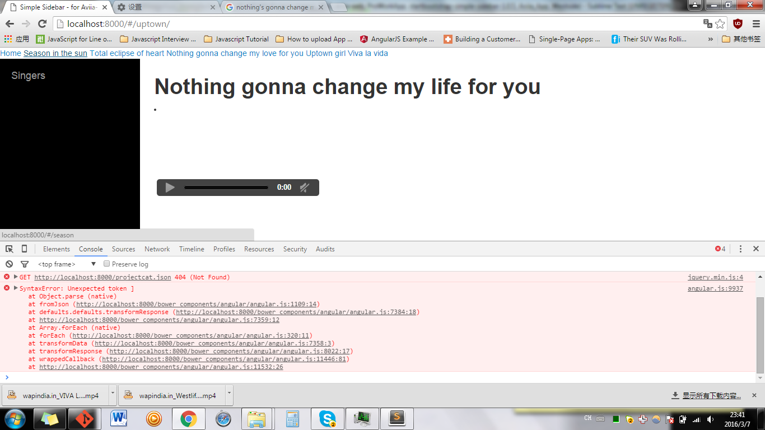

JSON

{"SINGERID":"300","SINGERNAME":"Billy Joel","SONGID":"501","CONTACTNAME":"Billy_uptown"},

{"SINGERID":"100","SINGERNAME":"Westlife","SONGID":"401","CONTACTNAME":"West_viva"},

{"SINGERID":"100","SINGERNAME":"Westlife","SONGID":"501","CONTACTNAME":"West_uptown**"},**

]}

WRONG: have one more comma